Mark Galesi

HTTP programming assignment

Case 1 output: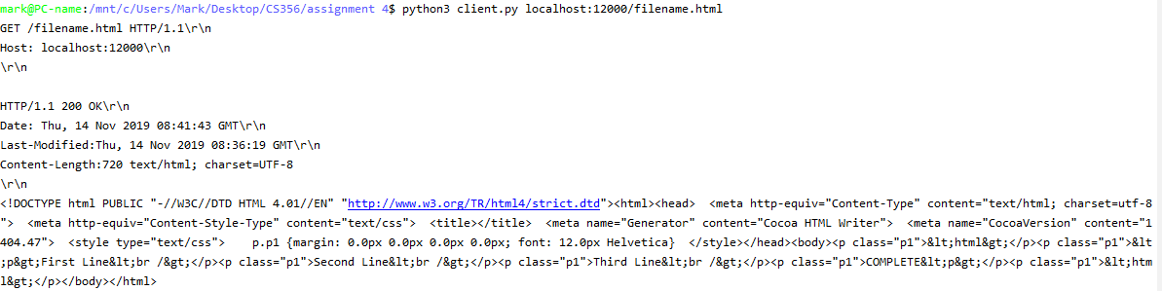

Case 2 output: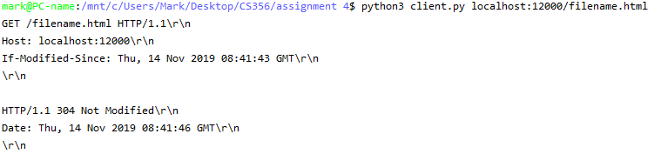

Case 3 output: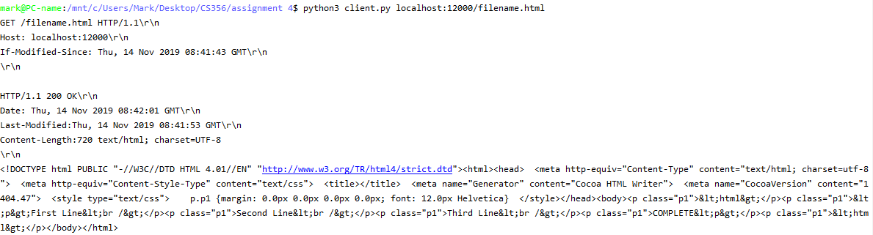

Case 4 output: